AMA Student Grant 2023 – Madison Ludwig

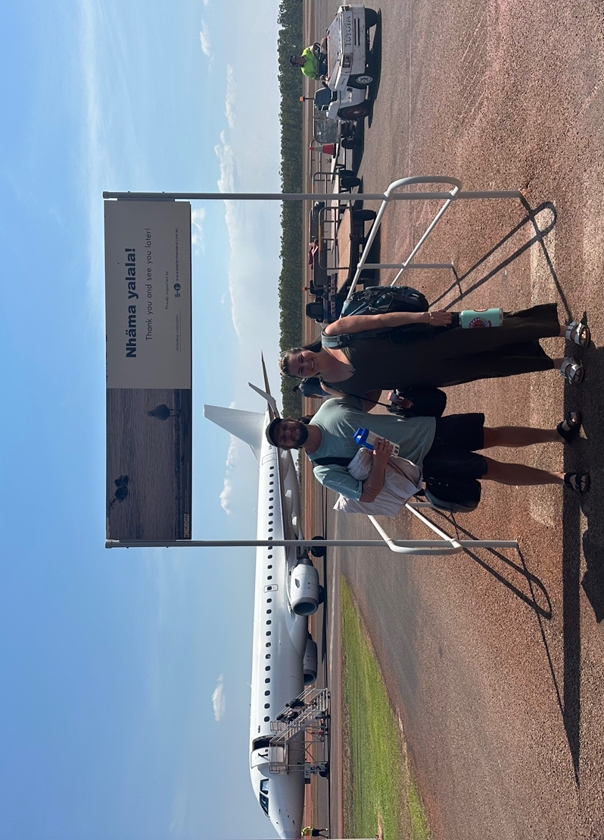

For the second semester of my third year of medicine through the NTMP, I chose to go to Nhulunbuy, in East Arnhem Land for my 20 week Community Based Placement.
This included placement in the ED, General Ward and Maternity Ward at Gove District Hospital, as well as a month based in the three clinics across Groote Eylandt. Overall, I had a phenomenal time on placement and will be forever grateful or the opportunity to spend so much time on such beautiful country.

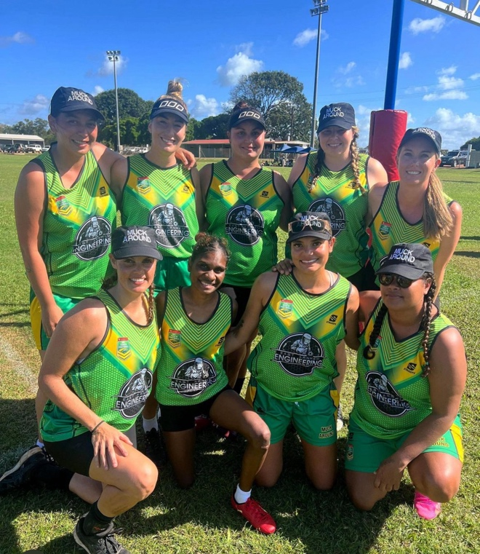
During my time in East Arnhem Land I had plenty of opportunity to explore the local country by boat, sea and air! I was also able to make time for plenty of extra curricular activities such as playing in the annual Dave Langridge Touch Tournament (team photo pictured to the right), compete in the annual Rotary beach volleyball contest, try my luck at a few golf tournaments, help out with one of the local football teams doing some sports training, as well as going fishing, camping and exploring on the weekends!

Receiving the AMA Student Grant allowed me to participate in activities such as these by reducing the financial burden on myself. I believe that being able to be involved in the local community through things such as social sport and volunteering helped to make my experience in Nhulunbuy and Groote such a memorable one!

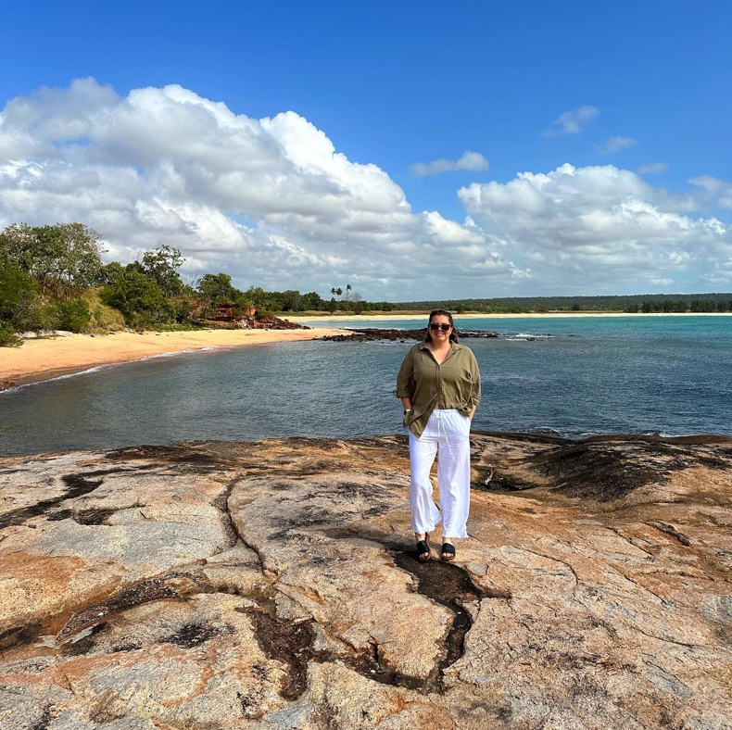
During my placement in Nhulunbuy, we spent a lot of time learning language and culture from local elders and also from the local students studying their diplomas in health care. This included weekly visits to a primary school, weekly language classes, fishing trips, hunting for bush medicine and spending time exploring country. This was an incredible opportunity to learn about different knowledges and understandings of not just health care but of life in general. In addition to this we were also given the opportunity to attend the yearly Garma Festival. Attending this festival gave us further opportunity to engage with the local culture, language, customs, dance and knowledges. We were able to talk to members of the public and other stakeholders about the NTMP and how it is structured. Many people were very interested to learn about out program and what opportunities we had to be out in Arnhem Land on placement, and were surprised to hear that we could study our whole degree here in the NT.

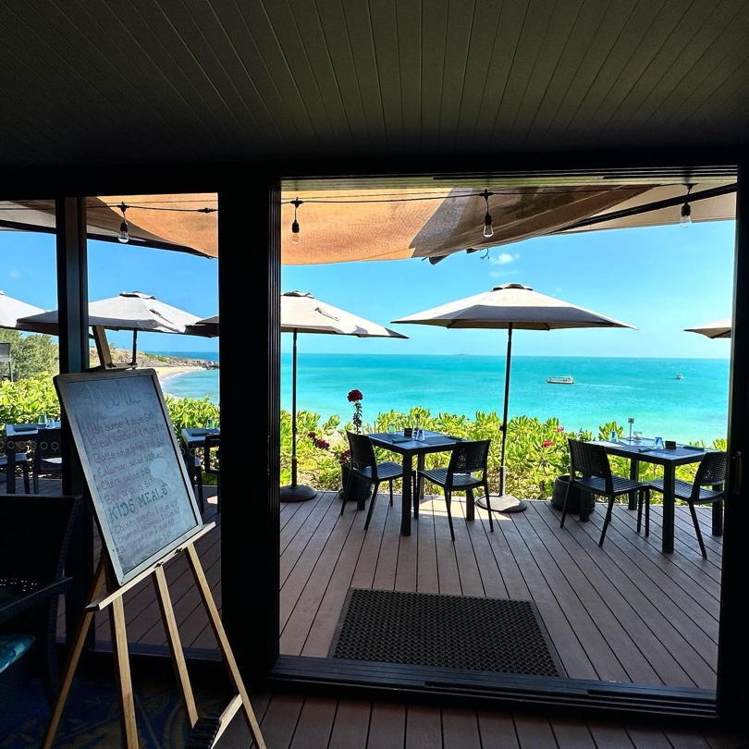
I was able to spend plenty of time on the weekends visiting local attractions such as Banu Banu Resort (pictured to the left), Cape Arnhem, Memorial Gorge, and many more excellent camping spots! Having the opportunity to visit these incredible places was a very special part of my time in East Arnhem.

Not only this, but we were also able to travel and visit multiple remote communities as part of the placement itself. During my 20 weeks I was lucky enough to travel to Groote Eylandt multiple times, Galiwinku, Gapuwiyak and Dhalininybuy. Being able to travel to these locations and see where my patients are coming from helped me with understanding their healthcare needs and the barriers that they may face.

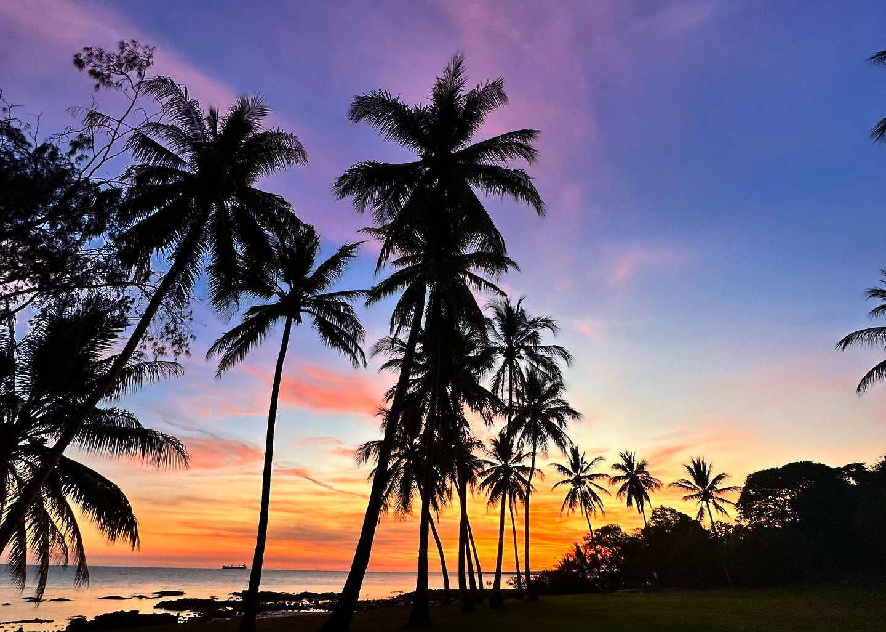

Towards the end of my 20 week placement, the team in Nhulunbuy were able to facilitate me going to spend 4 weeks on Groote Eylandt as part of my placement. This was such a special experience for me as I lived on Groote Eylandt as a child and hadn’t been back since the early 2000’s. My time on Groote consisted of rotating through the three on-Eylandt clinics, Alyangula, Umbakumba and Angurugu. This was a great clinical experience due to the diversity seen across the clinics and the range of patient presentations that I was able to see. Not only this, but I was able to connect with old friends and even family members who live and work on Groote, and once again get involved in the local social sport and activities. My month on Groote was definitely one of the highlights of my placement, and is a place that I would love to go back to and work at one day.

Thank you very much to the AMA NT for their financial support of me whilst on this placement. I would definitely encourage all NTMP students to make the most of their rural placements both clinically and socially, and I couldn’t recommend Nhulunbuy and Groote Eylandt enough!

